Exercise 11
1. Count the number of employees who have been with Bignet for four or more years.
SELECT COUNT(*) FROM employee_data WHERE yos >= 4;
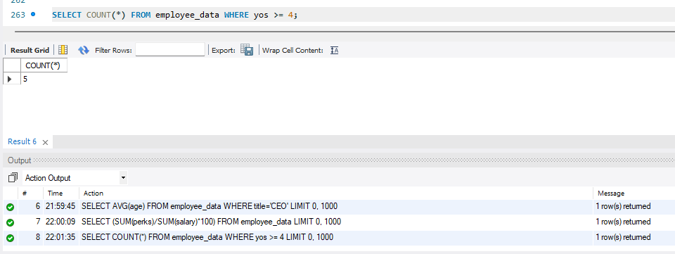
2. Count employees based on their ages.
SELECT age, COUNT(*) FROM employee_data GROUP BY age;
